

Assignment No: 01

Dated:10-11-2022

Topics: Water Fall Model? Its Pros and Cons?
Software Development Life Cycle?
Use Case and Domain Model?
Non-Functional Requirements?

Subject Name: Introduction To Software Engineering

Teacher Name: Sir Shakir Rasheed Khan

Student Name: Aryan Zaheer

Registration No: 4350-FBAS/BSSE/F21-B

Department of Software Engineering

Faculty of Basic&Applied sciences

Question No: 1
Describe the Waterfall Model and list the stages of water fall model also list three advantages and disadvantages of this model?
Solution:
The water fall model was the first process model to be introduce. It is very simple to understand and use. In a water fall model each phase must be completed before the next phase can begin and there is over lapping in the phase. The water fall model is a sequential design process in which process is seen as flowing steadily downward (like water fall).
The stages of water fall model are given below:
• Requirements
• System design
• Implementation
• Integration and Testing
• Deployment of system
• Maintenance

Advantages:
● Simple, easy to understand and use.
● Well understood milestones
● Process and results are well documented
Dis-advantages:
● No working software is produced until late during the life cycle
● High number of risks and uncertainty
● Poor model for long projects

Question No: 2
List the stages of the software development lifecycle (SDLC). Describe each case in 1 phrase each?
Solution:

The following are stages of software development lifecycle:

1. Ideation:
Brainstorming ideas that solve a particular problem faced by target users.
2. Requirements:
Interacting with stakeholders and users to collect and document project requirement.
3. Design:
Creating the architecture of a software system and its elements.
4. Development:
Building the software using a programming language by the development team.
5. Testing:
Evaluating the quality of a software with the aim of finding and fixing defects.
6. Deployment:
Preparing the software to run and operate in a specific environment.
7. Maintenance:
Updating and supporting the software after it has been delivered to the market.
Question No: 3 Solution:
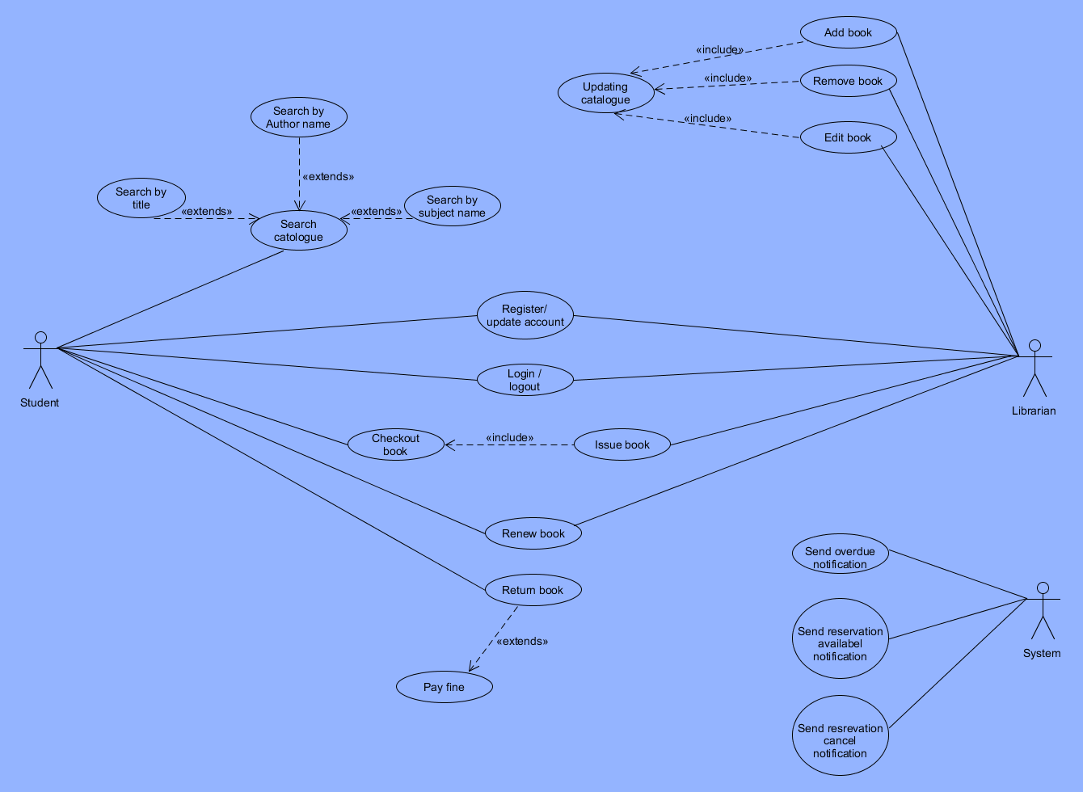

Question No: 4 Solution:
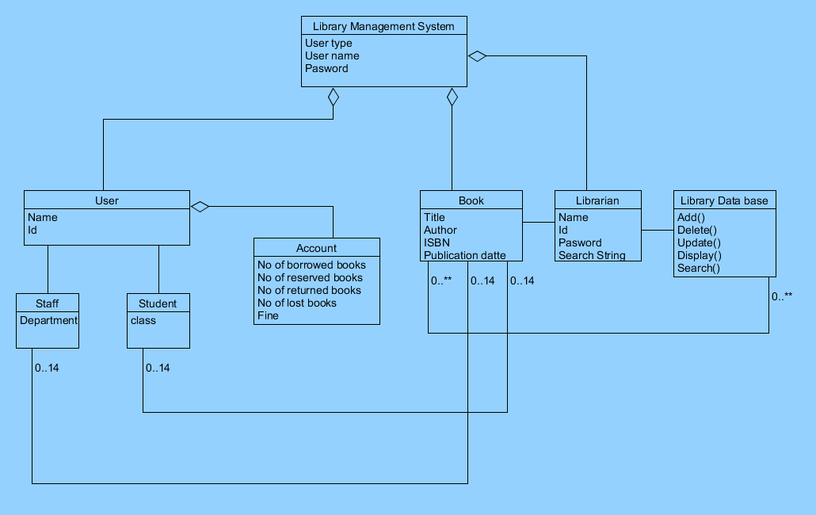

Question No: 4
Write the non-functional requirement for the following 2 projects?
- An online banking system:
• Security
• Performance
• Usability
• Availability
2. Bike racing game:
● Game should load within a second.
● Game should have realistic 3D characters.
● It should work very fast with out any buffer.

Introduction to Software Engineering use case Project Team :
- Aryan Zaheer- 4350/BSSE/F-21/SEC-B
- Suleman Faiz - 4349/ BSSE/F-21/SEC-B
- Usama Umar- 4356/ BSSE/F-21/SEC-B
- Saad Ishaq-4355/ BSSE/F-21/SEC-B
- Mohsin Waheed-4335/ BSSE/F-21/SEC-B

“HIDER”
Logo:


“Your safety is our priority”

Project manager:

Project manager task is usually to divide the task between the members and tell them what work to do.It define the scope of project in which direction it will go forward and ensures that it will go in right direction.Project manager distribute the whole system into modules and plans

Requirement analyst:

It usually finalize the required document and ammend any changes if required and if it is right then it will procced and go futher to the all stakeholders to get approved from them.

Manager QA:

The Quality Assurance (QA) Manager define the resources and also finalize the QA stock which will be used .It will wirte the test cases and also identify the edge cases.

Manager SW Testing :
The Test Manager takes full responsibility for the project’s success. The role involves quality & test advocacy, resource planning & management, and resolution of issues that impede the testing effort.

Manager UI:
UI/Usability Design Manager manages a team of designers that apply user-centered design principles to improve the workflow, expand the functionality, and enhance the visual appeal of websites and mobile apps.

Designer :

Designer usually desgin the user interface and aslo define the user experience and share all the design files to the people involved in your team

Objectives:
To develop a system which can help user to find results against his queries.It help parents to keep a check on their child online it also help adults to keep their little one safe from unnecessory mess of internet

Existing system:
Google
Opera
Uc Browser
Firefox

Problem Statement:

Everything can have access to everything online which makes our childs venerable to online distractions and spams.So we are developing a system where parent can control and keep track of their child activities.
Children are prone to the internet later dealing with stalking ,trolling,violence,sensitive audio and video contents.

Vision:
Making internet safe place for children.
Helping user to find their equerry.
Parent will be able to monitor their children.

Scope:
Since the main purpose of our project is to provide an anonymous extension to every device that to restrict user from getting access to unauthorized part of internet.
This will be designed in such a way that even proxies will not be able to break it's security. Extension will work the whole day and there will be a monthly cost for it's service. It will have child account and a parent account. For child, in case of any sensitive search, parent will get notification on their E-mail. The whole data of user will be private and protected.

Proposed System Functionality:
The work flow of the extension is kept simple in order to make it user friendly. To allow extension to get added in chrome or any other web, it will ask for permission, once it is permitted, it will ask for account information either it is parent or child. Only 18+ person can register extension. If account is child, it will ask for child information for example his date of birth and CNIC and parents information as per rule. Once account is created, only parent will be able to remove extension. Extension will work in backend and will not appear on screen. Extension will also remember all the devices in which it has logged in to make it more effective. It will not be able to crack by proxies or any other software. Child can check history and browse on internet. In case ,child attempts to visit sensitive site, he/she will be restricted and parents will be notified through email. While logging in, parent will be able to pay online through bank account and after that this will be practiced after every month.

What is “Hider”?
Hider is an extension. It’s basic purpose is to allows the parents to give their children access to the web making sure that the don’t get tricked while using internet. This project is designed keeping in view the increasing rate of cyber crimes with teenagers.

“Hider” requirements

ADMIN:

Admin is the service provider. Admin has faculty members responsible for various functioning of the search engine. Admin can control the whole system.
Admin can manage data that is
● Common Data: which is non restricted for all users.
● Sensitive Data: Which is restricted for under ages and some is also restricted for adults.
● History Management: admin can also manage history and can store it in a private storage for security purposes.

Transaction details:
When user will pay the charges to bank will update the transactions in the application. Admin can check those updates anytime. In case of any issue, he can consult to bank management team.

PARENTS:
Requirements from Parents:
- Parents will need to register their account then they have to pay fee to use this extension. Once registration is completed, they can on the extension.
Role:
When the extension will on the sensitive data will not be able to access.Child can access only common data.
Transactions Process:
2. Once parents have paid charges, then they can check transaction history online.

CHILD:

- When child will use search engine and surf through common data.
- If child searches some irrelevant data or some risky websites that will banned due to HIDER extension.
- Child have access to see history.

BANK:
Bank will play central role with the among customer and service provider, once parents have paid charges bank will generate the transaction details and update it on application. A bank team will be specific for this process whose job will be to provide integration among the users and provider.

Use case Diagram:

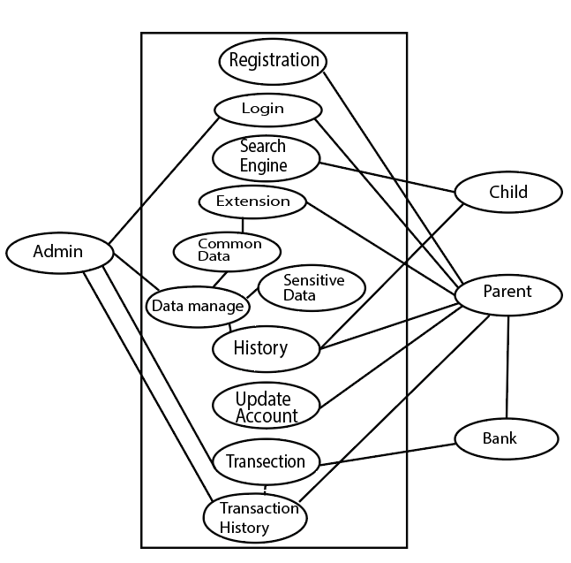

Introduction to Software Engineering use case Project Team :
- Aryan Zaheer- 4350/BSSE/F-21/SEC-B
- Suleman Faiz - 4349/ BSSE/F-21/SEC-B
- Usama Umar- 4356/ BSSE/F-21/SEC-B
- Saad Ishaq-4355/ BSSE/F-21/SEC-B
- Mohsin Waheed-4335/ BSSE/F-21/SEC-B

“Go Solutions”

“Your safety is our priority”

What is “Go Solutions”?
Go solutions is a search engine. It’s basic purpose is to provide web services and it allows the parents to give their children access to the web making sure that the don’t get tricked while using internet. This project is designed keeping in view the increasing rate of cybercrimes with teenagers.

Introduction to Software Engineering use case Project Team :
- Aryan Zaheer- 4350/BSSE/F-21/SEC-B
- Suleman Faiz - 4349/ BSSE/F-21/SEC-B
- Usama Umar- 4356/ BSSE/F-21/SEC-B
- Saad Ishaq-4355/ BSSE/F-21/SEC-B
- Mohsin Waheed-4335/ BSSE/F-21/SEC-B

“Go Solutions”

“Your safety is our priority”

What is “Go Solutions”?
Go solutions is a search engine. It’s basic purpose is to provide web services and it allows the parents to give their children access to the web making sure that the don’t get tricked while using internet. This project is designed keeping in view the increasing rate of cybercrimes with teenagers.

“Go Solutions” requirements

ADMIN:

Admin is the service provider. Admin has faculty members responsible for various functioning of the search engine. Admin can control the whole system.
Admin can manage data that is
● Common Data: which is non restricted for all users.
● Sensitive Data: Which is restricted for under ages and some is also restricted for adults.
● History Management: admin can also manage history and can store it in a private storage for security purposes.

Transaction details:
When user will pay the charges to bank will update the transactions in the application. Admin can check those updates anytime. In case of any issue, he can consult to bank management team.

PARENTS:
Requirements from Parents:
- Parents will need their own CNIC and child CNIC for registration. Once registration is completed, they can keep check and balance on their child.
Role:
2. In case of any sensitive search by child, parents will receive an alert through E-mail or text massage. They can restrict that search.
Transactions Process:
3. Once parents have paid charges, then they can check transaction history online.

CHILD:

- Child have only access to login, registration will be done by the authentication of parents.
- Child can use search engine and surf through common data.
- If child searches some irrelevant data or some risky websites that are banned in that particular region, parents will be informed through an alert about this action.
- Child have access to see history and also update account.
- When child reaches legal age, he can update this account through the authentication of parents.

BANK:
Bank will play central role with the among customer and service provider, once parents have paid charges bank will generate the transaction details and update it on application. A bank team will be specific for this process whose job will be to provide integration among the users and provider.
a
Use case Diagrame:
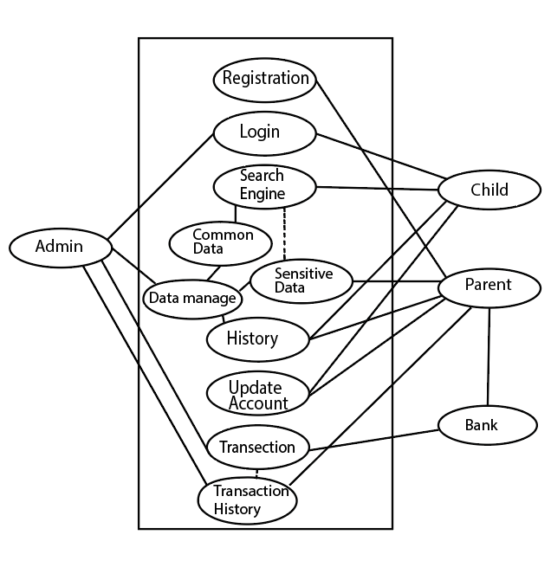

Domain Model:
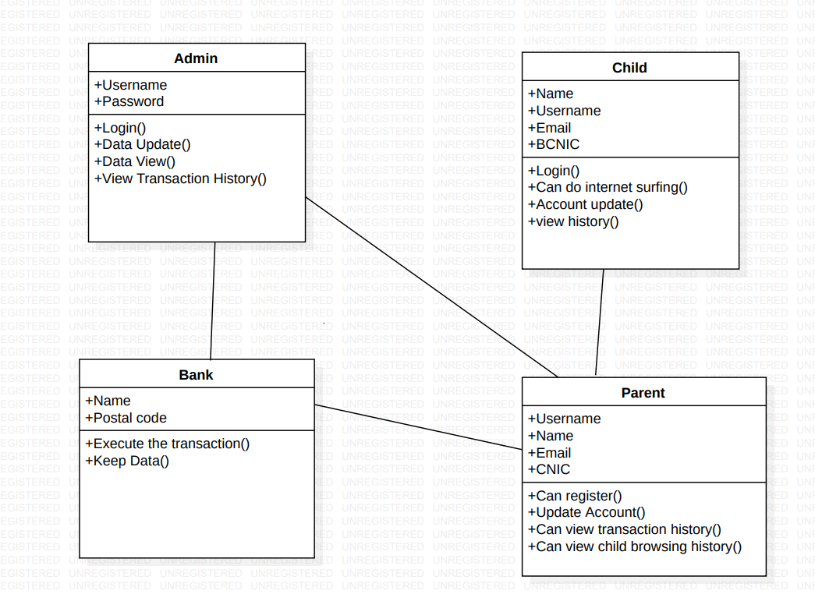

Characteristics:
Admin:
• Admin can login thorough admin portal, it can manage the whole data and web servers. It can keep the whole data of user for security purposes and can react to certain data accordingly.
• Admin will receive all transaction details through his integration team i.e working with bank. It can take proper actions against the uncertain situations.
Parent:
• Parent will have to provide their CNIC’s along with the child CNIC. The registration of account is not possible without the authentication of parent.
• Parent can pay charges online and offline and can check transaction updates on application’s website.
Child:
• Child will be use the login page of the account that has been registered by the parents. His all searches will be private except the sensitive searches.
• Any illegal site will be prohibited and parents will get to know about that.

Bank:
• Bank will have certain team working with him that will send all the transactions detail on website and will update there.

“Go Solutions” requirements

ADMIN:

Admin is the service provider. Admin has faculty members responsible for various functioning of the search engine. Admin can control the whole system.
Admin can manage data that is
● Common Data: which is non restricted for all users.
● Sensitive Data: Which is restricted for under ages and some is also restricted for adults.
● History Management: admin can also manage history and can store it in a private storage for security purposes.

Transaction details:
When user will pay the charges to bank will update the transactions in the application. Admin can check those updates anytime. In case of any issue, he can consult to bank management team.

PARENTS:
Requirements from Parents:
- Parents will need their own CNIC and child CNIC for registration. Once registration is completed, they can keep check and balance on their child.
Role:
2. In case of any sensitive search by child, parents will receive an alert through E-mail or text massage. They can restrict that search.
Transactions Process:
3. Once parents have paid charges, then they can check transaction history online.

CHILD:

- Child have only access to login, registration will be done by the authentication of parents.
- Child can use search engine and surf through common data.
- If child searches some irrelevant data or some risky websites that are banned in that particular region, parents will be informed through an alert about this action.
- Child have access to see history and also update account.
- When child reaches legal age, he can update this account through the authentication of parents.

BANK:
Bank will play central role with the among customer and service provider, once parents have paid charges bank will generate the transaction details and update it on application. A bank team will be specific for this process whose job will be to provide integration among the users and provider.
a
Use case Diagrame:

Domain Model:

Characteristics:
Admin:
• Admin can login thorough admin portal, it can manage the whole data and web servers. It can keep the whole data of user for security purposes and can react to certain data accordingly.
• Admin will receive all transaction details through his integration team i.e working with bank. It can take proper actions against the uncertain situations.
Parent:
• Parent will have to provide their CNIC’s along with the child CNIC. The registration of account is not possible without the authentication of parent.
• Parent can pay charges online and offline and can check transaction updates on application’s website.
Child:
• Child will be use the login page of the account that has been registered by the parents. His all searches will be private except the sensitive searches.
• Any illegal site will be prohibited and parents will get to know about that.

Bank:
• Bank will have certain team working with him that will send all the transactions detail on website and will update there.

